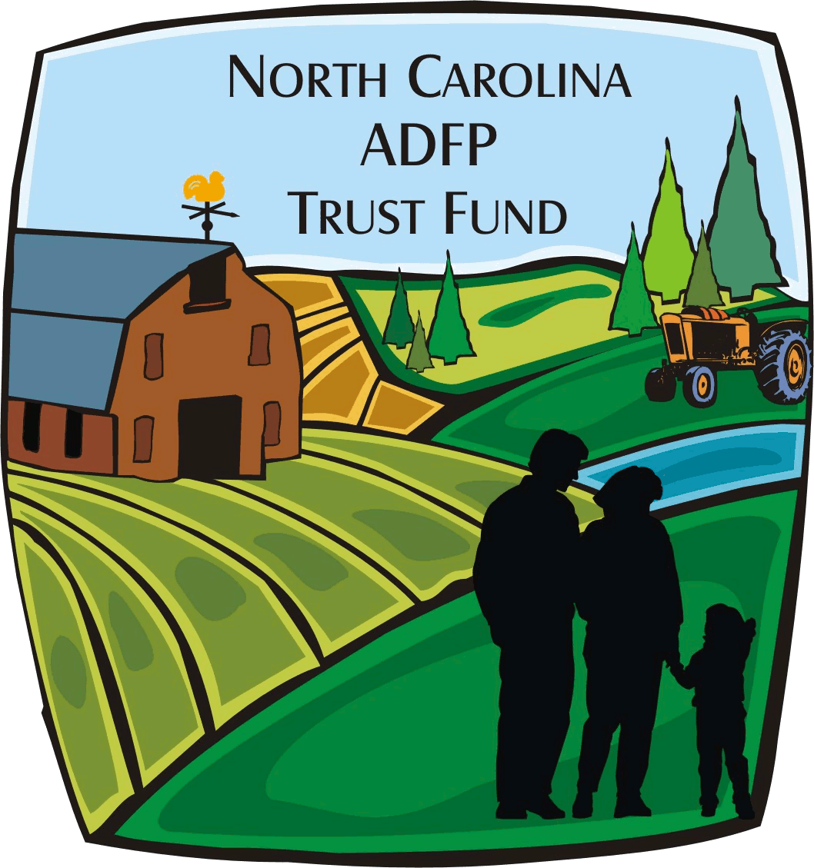
N.C. Department of Agriculture & Consumer Services
N.C. ADFP Trust Fund
Initial Request for Payment & Request for Reimbursement

See back for instructions.
I. Project Information
ADFP Tracking Number: ADM-ADFP- - | Date of Report:
Grantee:
Project Title:
Tax ID Number: | Project Start & End Dates: to
Reporting Period Start Date: | Reporting Period End Date:
Contract Number: | Request Number:
Type of Request (check one): Initial Partial Final

II. Initial Request for Payment
Grantees may request no more than $25,000 for the initial payment. If the total award amount is less than or equal to $27,780.00, no more than 90% of the total grant amount may be requested for initial payment. Grantees will be required to submit copies of invoices with documentation of payment with any quarterly or semi-annual budget reports.
Total Request for Initial Payment: $

III. Summary of Expenditures (Attach copies of invoices or other types of billing documents).
Budget Item # | Budget Category | Amount | Totals
 |  | $0.00 | Total Expenditures prior to this request: | $0.00
 |  | $0.00 | Total Expenditures for this request: | $0.00
 |  | $0.00 | Total Expenditures to date: | $0.00
 |  | $0.00 | Total Match prior to this request: | $0.00
 |  | $0.00 | Cash Match for this request: | $0.00
 |  | $0.00 | In-kind dollar value for this request: | $0.00
 |  | $0.00 | Total Match for this request: | $0.00
 |  | $0.00 | Total Match to date: | $0.00
Total ADFP Expenditures for this request: |  | $0.00

IV. Signatures
Certification: I certify that this information is correct and based on generally accepted accounting standards and principles. The above expenditures are based on actually payments of record for the purpose of and in accordance with the terms of the grant contract. The funds requested are for reimbursement of costs during time period indicated above and do not duplicate a previous request. The documentation will be retained in our files for future audits (Counties should use local government bidding requirements on projects).
Authorized Representative:  Name:  Title: | Telephone Number:  E-mail Address:
Signature of Authorized Representative: | Date:

For ADFP Trust Fund Use Only:
Approval by Budget Officer: | Approval by Office Manager:
Date: | Date:

Initial Request for Payment and Request for Reimbursement
You may make copies of this form as needed.

Initial Request for Payment Instructions (Fill in Sections I, II, and IV)

Upon execution of the contract, you may complete an initial Request for Payment form for an amount not to exceed $25,000. If the total grant amount is less than or equal to $27,778.00, no more than 90% of the ADFP fund can be requested at this time. Grantees will be required to submit copies of invoices with documentation of payment with any quarterly or semi-annual budget reports.
- Fill in the ADFP Tracking Number, Grantee, Project Title, Tax ID Number, Contract Number, and Date of Report in Section I.
- The Project Start & End Dates should correspond with the dates of your contract.
- The Request Number will be “1” since this is an initial request.
- Type of Request will be checked “Initial.”
- Enter the Total Request for Initial Payment in Section II.
- The grantee’s finance representative (as indicated on the Signature Card) should sign this form. Please provide a contact number and email address for this representative in case there are any questions.

Request for Reimbursement Instructions (Fill in Sections I, III, and IV)

- Requests for reimbursement may be made no more than once per month. These should be submitted by the 10th of the month.
- Fill in the ADFP Tracking Number, Grantee, Project Title, Tax ID Number, Contract Number, and Date of Report in Section I.
- The Project Start & End Dates should correspond with the dates of your contract.
- The Reporting Period Start Date should start with the 1st of any given month and the Reporting Period End Date should include the last date of any given month. For example, a reporting period could be July 1, 2013 – July 31, 2013 or July 1, 2013 – August 31, 2013, if submitting bi-monthly requests.
- The Request Number is used to indicate whether this is the second, third, etc. requesting being made.
- Type of Request will be checked “Partial” unless you are submitting your final request for reimbursement.
- In the Summary of Expenditures provide the following:
  - The budget item number in which expenditures have been made in the “Budget Item #” column. (Budget item numbers are listed on page 3 of the General Instructions as well as on the budget report)
  - The budget categories in which expenditures have been made in the “Budget Category” column. (Budget categories are listed on page 3 of the General Instructions as well as on the budget report).
  - The “Expenditures” for each category listed.
  - The “Total ADFP Expenditures for this request” will be calculated.
  - The “Total Expenditures prior to this request” will calculate with “Total Expenditures for this request” for a cumulative figure as “Total Expenditures to date.”
  - List any Cash or In-Kind prior to and for this request.

- The grantee’s finance representative (as indicated on the Signature Card) should sign this form. Please provide a contact number and email address for this representative in case there are any questions.

NOTE: NC sales tax is not eligible for reimbursement. Please contact us if you need further information on how to get reimbursed for sales tax.

