N.C. Department of Agriculture & Consumer Services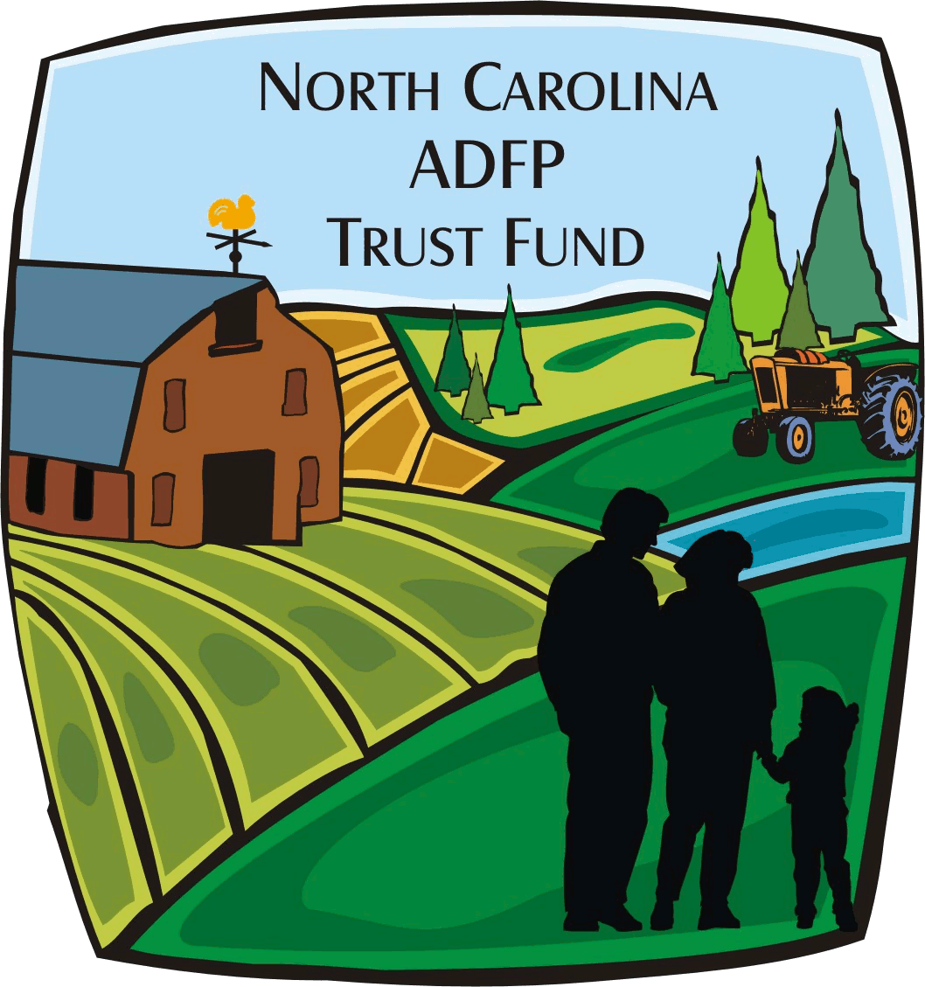
N.C. ADFP Trust Fund
Budget & Progress Report – Perpetual or Term Easements

See back for instructions.
I. Project Information
ADFP Tracking Number: ADM-ADFP- - | Date of Report:
Grantee:
Project Title:
Tax ID Number: | Project Start & End Dates: to
Reporting Period Start Date: | Reporting Period End Date:
Contract Number:

II. ADFP Funds Report
Expenditure Categories | Initial Contract Budget Amount | Previously Reported Expenditures | Balance at Beginning of this Reporting Period | Expenditures for this Reporting Period | Ending Balance for this Reporting Period
211 Stewardship Endowment | $0.00 | $0.00 | $0.00 | $0.00 | $0.00
212 Survey | $0.00 | $0.00 | $0.00 | $0.00 | $0.00
214 Baseline Documentation Report | $0.00 | $0.00 | $0.00 | $0.00 | $0.00
215 Environmental Assessment / Audit | $0.00 | $0.00 | $0.00 | $0.00 | $0.00
216 Legal Fees | $0.00 | $0.00 | $0.00 | $0.00 | $0.00
217 Closing Costs | $0.00 | $0.00 | $0.00 | $0.00 | $0.00
220 Easement Purchase | $0.00 | $0.00 | $0.00 | $0.00 | $0.00
Totals | $0.00 | $0.00 | $0.00 | $0.00 | $0.00

III. Matching Funds Report
Total Match Prior to this Report: $0.00

Expenditure Categories | Source of Funding | Amount of Match | Cash or In-Kind | Cost per unit & # of units | Description of Expenditures | Notes
 |  | $0.00
 |  | $0.00
 |  | $0.00
 |  | $0.00

Total Cash Match for this Report: $0.00 | Total In-Kind Match for this Report: $0.00
Total Match for this Reporting Period: $0.00 | Total Match to Date: $0.00

IV. Progress Report
Status of Document Suites | Status of Document Suites
Name of Document Suite Turned in: | Next Due Date:
Extension Requested on Which Suite: | Next Due Date:
Formsite link for deliverable extension: https://fs30.formsite.com/ADFPTrustFund/lrefxgtjks/index.html

V. Signatures
Certification: I certify that this information is correct and based on generally accepted accounting standards and principles.
Signature of Authorized Representative: | Date:

For ADFP Trust Fund Use Only:
Approval by Budget Officer: | Approval by Farmland Preservation Specialist:
Date: | Date:
Budget & Progress Report
You may make copies of this form as needed.

- Fill in the ADFP Tracking Number, Grantee, Project Title, Tax ID Number, Contract Number, and Date of Report in Section I.

- The Project Start & End Dates should correspond with the dates of your contract.

- In Section II, list the contracted budget for each line item in the second column under Initial Contract Budget Amount.

- List any expenditures prior to this reporting cycle under Previously Reported Expenditures for the corresponding budget line items.

- Under Expenditures for this Reporting Period, please report all ADFP expenditures of this reporting period only.

- If no expenses have been incurred, please indicate such.

- Funds, up to 10%, can be moved within the approved line items without prior approval. Any amount above 10% will require prior approval of the Budget Officer. No new line items will be allowed without prior approval of the Program Manager and the Budget Officer.

- NOTE: ADFP Trust Fund monies CANNOT be used for Travel, Personnel & Administrative, Steward Endowment, or Appraisal.

- In Section III, please enter the Total Match Prior to this Report in the first box.

- Please list all matching funds received for this project during this reporting period. The expenditure category of the matching funds can be designated from the drop-down menu in the first column.

- Cash and In-Kind matching funds will be designated by “C” or “IK” from the drop-down menu in the fourth column.

- Calculate the amount of “Cash” matching funds, if applicable, beside Total Cash Match for this Report.

- Calculate the amount of “In-Kind” matching funds, if applicable, beside Total In-Kind Match for this Report.

- For salaried or hourly personnel services provide the rate of pay and number of hours worked. For contracted personnel services provide proof of payment.

- In Section IV, enter the document suite completed for this period, and acknowledge the due date of the next document suite, OR the new due date based on the extension requested.

- Please attach supporting documentation such as time sheets, copies of checks, invoices with documentation of payment, or other billing documents that verify expenses. (See www.ncadfp.org for more details on documentation)

- The grantee’s finance representative (as indicated on the Signature Card) should sign this form. Please provide a contact number and email address for this representative in case there are any questions.

