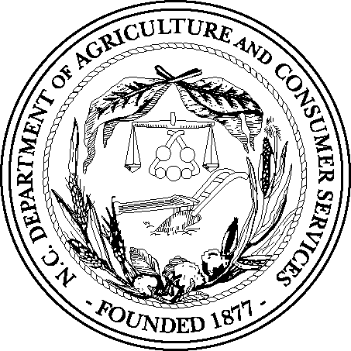

NORTH CAROLINA DEPARTMENT OF AGRICULTURE & CONSUMER SERVICES FOOD AND DRUG PROTECTION DIVISION

APPLICATION FOR

□ NCDA&CS HAULER AND SAMPLER LICENSE (see attached Directions)
□ GRADE "A" MILK HAULER/SAMPLER PERMIT

GRADE "A" H/S PERMIT NUMBER: ______________________

INITIAL DATE OF TRAINING: _________________ DATE PERMIT ISSUED:____________

Applicant information:

Name:

Address: County:

Phone Number:

Cell/Emergency Phone Number:

Email:

Other:

Employer Information: _________________________________________________

Company Name:

Address: County:

Phone Number:

Contact Person:

Contact Cell/Emergency Number:

Email:

Amount Enclosed: $
Applicant Signature: Date:

Directions for NCDA&CS Milk Hauling and Sampling License:

§ 106-267.1. License required; fee; term of license; examination required. - Every person shall first obtain a license from the Commissioner of Agriculture. Any person applying for such license or renewal of license shall make written and signed application on blanks to be furnished by the Commissioner of Agriculture. The granting of a license shall be conditioned upon the passing by the applicant of an examination, to be conducted by or under the direction of the Commissioner of Agriculture. All licenses so issued or renewed shall expire on December 31 of each year, unless sooner revoked, as provided in G.S. 106-267.3. A license fee of five dollars ($5.00) for each license so granted or renewed shall be paid to the Commissioner of Agriculture by the applicant before any license is granted.
Beginning June 1, 2012 Food and Drug will honor the Grade A permit for milk samplers and haulers; however, to meet the above Article 29 requirement, the applicant shall submit this application along with the$5.00 license fee. The license shall expire on December 31 of each year.
Make check payable to: NCDA&CS/ Food & Drug Protection

Mail completed application and check to:

NCDA&CS
Food & Drug Protection Division
1070 Mail Service Center
Raleigh, NC 27699-1070

