**Cattle Eye Conditions to Suspect on Ante-Mortem**

Cattle missing an eye

Any growth or tissue enlargement on or around the eye

Abnormal bulging, swelling, and/or redness of the eye

Cattle with smaller than normal eyes

Any other condition that removal of the hide will hinder the veterinarian from making a disposition

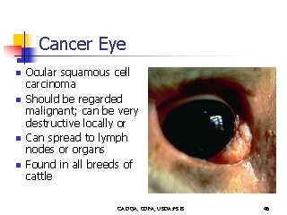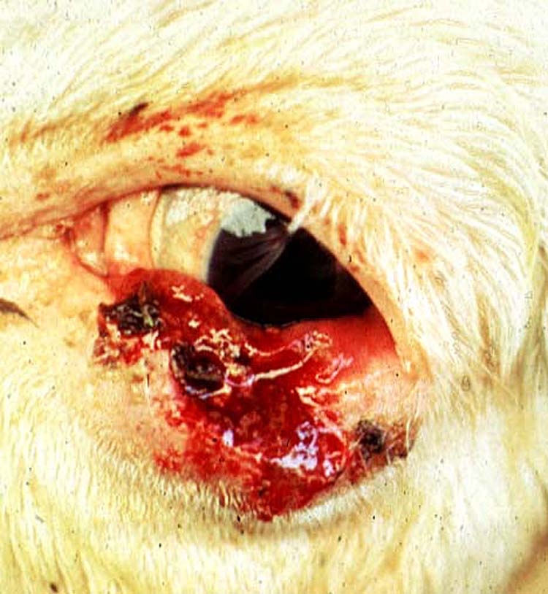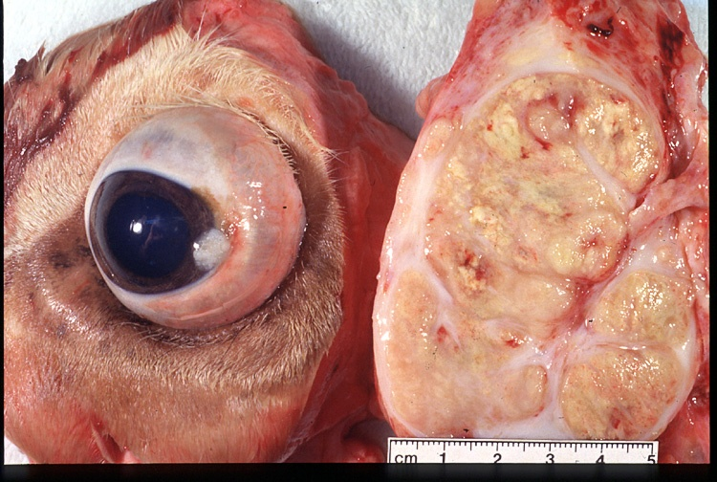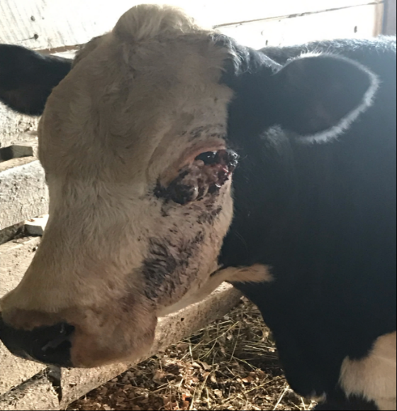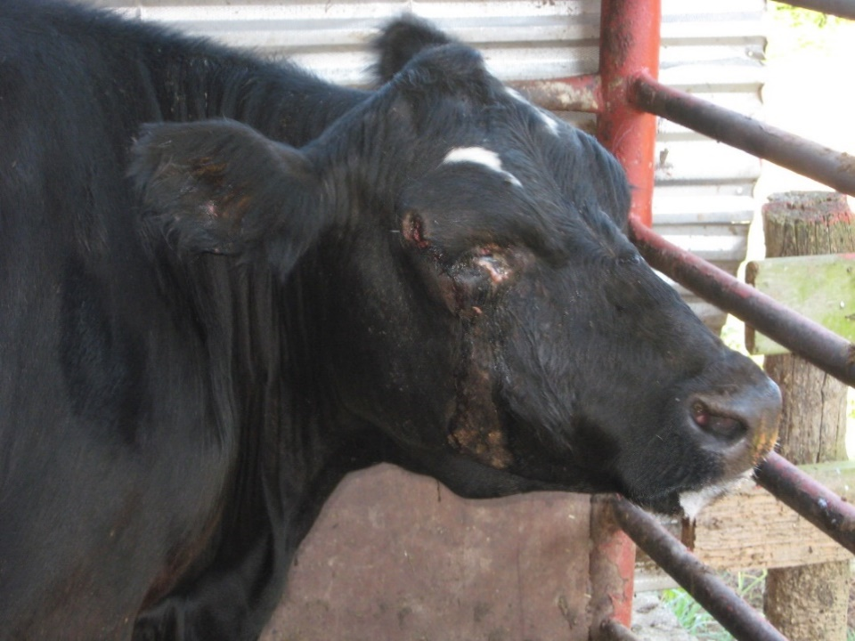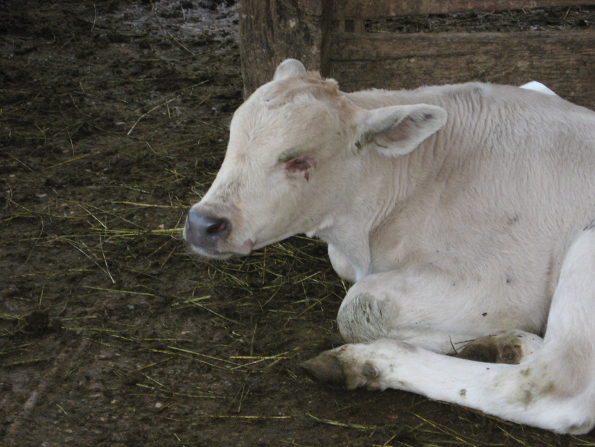 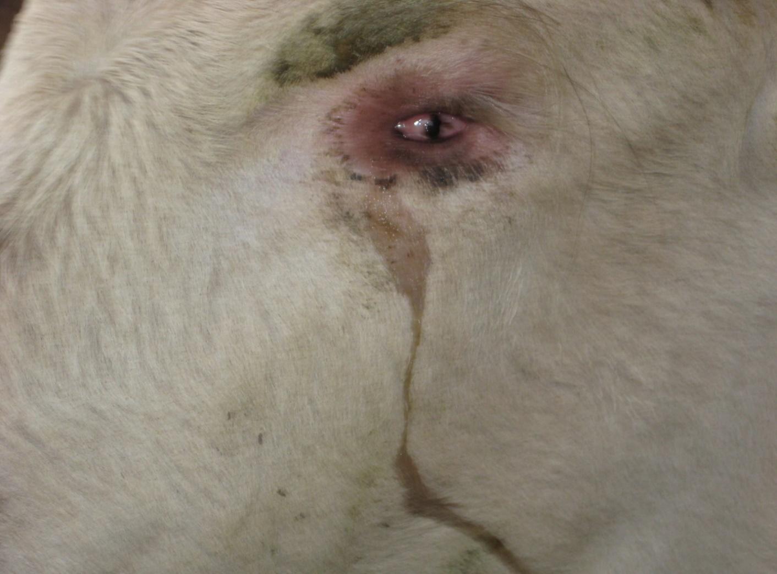

**Cattle Eye Conditions that can be retained on Post-Mortem Inspection**

These conditions do not always need to be retained on Post-Mortem Inspection. Only retain these conditions when there is other pathology seen along with the eye condition.

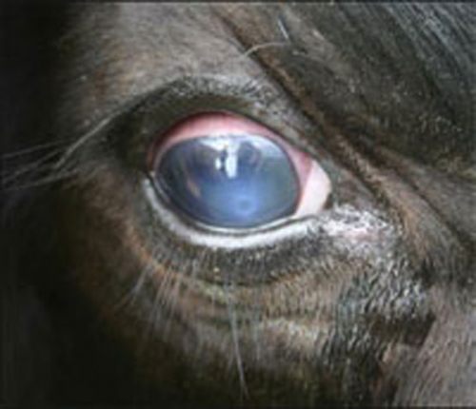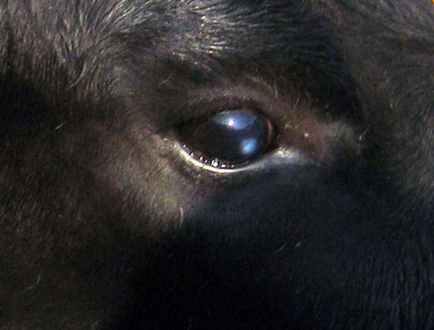

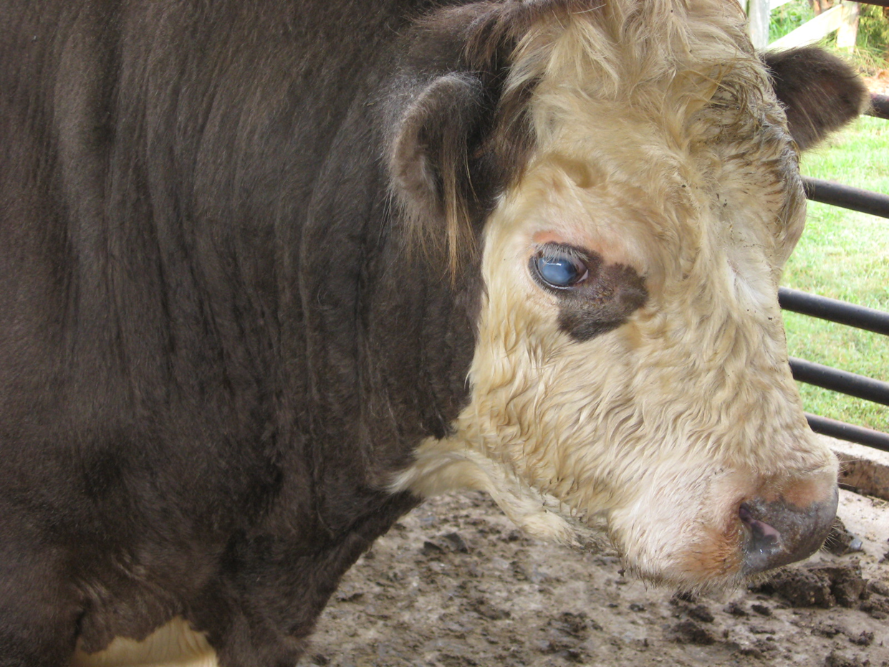

*Any of these conditions that are seen in cattle that are circling or appear to be blind should still be suspected on Ante-Mortem