Sampling Instructions for Fully Cooked, Not Shelf Stable Products

For use with MPID-Form 27.3

I. Prior to Sample Collection
- Check contents of shipper upon arrival. The shipper should contain:
Foam Plug
Request for Sampling Form
FedEx US Airbill
2 ice packs
Cardboard mat
Clear plastic Whirl-Pak bag (to place final intact product in)
Large white plastic bag (to place sample box into prior to placing in the establishment’s cooler)
2 sample security seals

- Contact the Raleigh Office at MPIDSampling@ncagr.gov immediately if you are missing supplies, if your gloves become contaminated, if there is not a security seal on the outside of the box or it shows evidence of being tampered with. The microbiologist places a seal on the outside of the shipping container before it is shipped from the lab.

- Place ice packs in freezer at least 24 hours prior to sample collection. In the hot summer months, be sure to have at least two (2) pre-frozen ice packs on-hand to ship with samples to prevent sample rejection.

- Save shipping container. Place the open shipping container inside the large white plastic bag provided. Place the bag, containing the shipping container, in the cooler or refrigerator at least 24 hours prior to sample collection. The shipping containers can get very dirty from being sent back and forth from the lab to the establishment. These bags will reduce the chance of the containers introducing any contaminants into the establishment’s cooler. This should also assist in reducing moisture damage to the boxes.

- Place all other materials in a secure location until sample collection.
- Inspectors should notify their supervisor and email MPIDSampling@ncagr.gov when a sample cannot be collected during the scheduled timeframe as soon as made aware. They should hold onto the lab supplies and collaborate via that email for the next available collection date.

II. Procedures for Establishment Notification of Upcoming Sample Collection

- When inspection personnel are rotated into an unfamiliar establishment, they are to discuss sampling with the establishment during a weekly meeting. As part of this discussion, inspection personnel are to determine how much notice to give the establishment before collecting a sample.

- Provide establishment management sufficient notification of the sample collection and provide them enough time to hold the sampled lot, but not enough time to alter the process.

- As per FSIS Directive 10,240.3, IPP are to:

  - “Generally, provide one day’s notice if such advanced notice is sufficient for the establishment to hold the sampled lot, but not to change practices. IPP may provide two days’ notice, if necessary.
  - Consider the establishment’s request for more than two days’ notice, in the rare case that more notice is needed based on the establishment’s product and process flow. If the establishment can support that more notice is necessary because of the innate characteristics of the process (e.g., less-than-daily sanitation, use of brine, or processes that span more than two days), IPP may provide more than two days’ notice.

  - If IPP have questions about an establishments’ basis for requesting more notice, they are to discuss them with their supervisor.”

NOTE: A request for more than two days can be expected in small and very small establishments. It provides the establishments the opportunity to schedule their production accordingly so they can fill orders, especially those establishments that produce a lot of “make to order” type products that must be filled in a short time. Requests for more than two days’ notice should be considered on a case-by-case basis.

- Inform establishment management of the reason that a sample is being collected (e.g., routine monitoring, or follow-up sampling in response to a Lm positive result). Also, inform the establishment that it is required to hold or maintain control of the sampled lot when MPID collects samples for Lm and Salmonella until negative results become available. Negative laboratory results will be available within 48 hours. Positive or inconclusive results will require laboratory work that may take a week or more.)

III. Determination of the Establishment’s Sampled Lot

- As per FSIS Directive 10,240.3:
  - “The sampled lot is product that is represented by the sample FSIS collects and analyzes for Lm and Salmonella. The establishment is responsible for defining the sampled lot.
  - FSIS generally considers the sampled lot to be the product produced from “clean-up to clean-up,” unless the establishment has a different supportable definition of the lot (e.g., products are produced on different lines and that are microbiologically distinct from one another).
  - An official establishment may reduce its lot size on a day when FSIS collects a routine RTE sample to facilitate holding the product if the change does not interfere with FSIS’ ability to collect a representative sample.
NOTE: For example, an establishment that normally produces product over an 8-hour shift, followed by a complete clean-up, may reduce its lot size when FSIS collects a sample. The establishment may then produce product over a 4-hour period, followed by a complete clean-up.
  - There are other options that establishments may use to reduce lot size, if FSIS can still collect a representative sample. Instructions to verify an establishment’s written sampling program design and execution can be found in FSIS Directive 10,240.4, Listeria Rule Verification Activities, Chapter III.
    - IPP are to be aware that establishments may reduce the lot size even when using source materials that are post-lethality exposed and do not undergo further lethality treatment. The establishment is not required to hold other lots using the same source materials because the sampled lot is those products produced from clean-up to clean-up.
    - For example, if an establishment reduces the lot in the production of prepared chicken salad using RTE post-lethality exposed chicken from another supplier, the establishment may reduce its lot size to a 4-hour period of chicken salad production, followed by a complete clean-up. The establishment can make another lot of chicken salad using the same source materials and not hold that lot. In the event of a positive, the establishment will need to provide a scientific basis to justify why the other lots should not be implicated.”

NOTE: See FSIS Directive 10240.3 for more information about the “sampled lot” vs. “implicated lot” in the case of a Lm and/or Salmonella positive result.

IV. Collection of Sample

- Inspection personnel are only to collect samples, when directed.

- Select the highest risk Fully Cooked, Not Shelf Stable, post-lethality exposed RTE product produced at the time of collection. The product priority ranking is provided below:

- Other fully cooked sliced product
- Hot dog products
- Salads/Spreads/Pate
- Meat + Nonmeat Components
- Sausage Products
- Patties/Nuggets
- Other fully cooked not sliced products

  - If multiple Fully Cooked, Not Shelf Stable, post-lethality exposed RTE products eligible for sampling are being produced on the date of collection, the following should also be considered when deciding on the product to sample:
    - The historical percent positive for each eligible product being produced.
    - The daily production volume of each eligible product being produced.
    - The Listeria alternative used for each eligible product being produced. As per FSIS Directive 10,240.3, Table 1 the sampling priority is as follows:
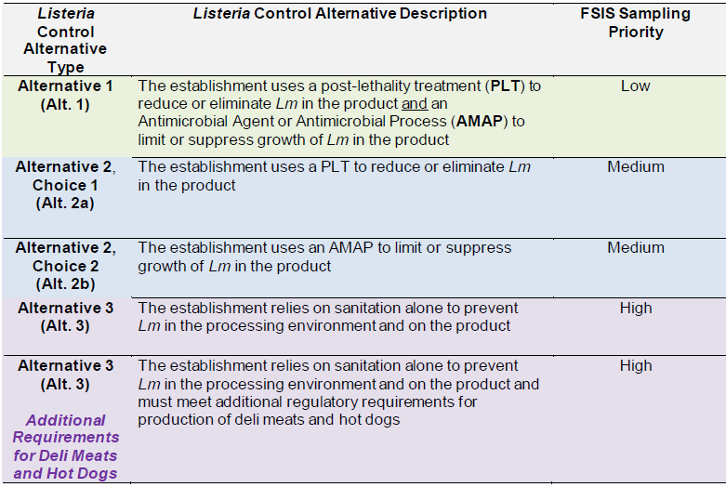
- IPP are not to sample the following:
- Oils, shortening, lard, margarine, oleomargarine, or mixtures of rendered animal fats.
- Pass-through product, which is fully packaged finished product that the establishment has received and kept its package without further post-lethality exposure, processing or repackaging.

V. Sampling Procedure

- When possible, product eligible for this sampling procedure should be collected in its final packaged form.

  - If the establishment only packages product in containers larger than one pound, the establishment may short-weight or slack-fill a container. In such cases, the sample must be produced in the same way as the rest of the product it represents; the only difference would be the size of the package.

  - If the finished product will not fit into one of our standard shipping boxes (even if it is slack-filled), please call the Raleigh Office. Broken or unlabeled containers will not be accepted.

- Collect a fresh one-pound sample of the chosen Fully Cooked, Not Shelf Stable, post-lethality exposed product. Multiple packages from the same production lot can be collected and submitted to make one-pound total weight.

  - The sample should be collected at least three hours after the start of production, whenever possible, to allow Lm to work its way out of the equipment. If the establishment’s production lot is typically less than three hours, the sample should be collected as close towards the end of the production lot as possible.

  - The sample should be submitted to the laboratory after the establishment has completed all interventions. However, if an establishment has any intervention based on microbiological test results, do not wait for the establishment to receive microbiological test results before sending the sample to the laboratory.

- Place the sample in its final packaging in the Whirl-pak bag provided by the lab.

    - To open the Whirl-pak bag, remove the tear strip from the top, grasp the two small white tabs and pull apart.

    - Once the sample is placed in the Whirl-Pak bag, close it by folding the top of the bag down a few times, and folding the wire attached to the bag inward against the bag.

    - Place the small security seal over the top, so that the seal is sticking to the sides of the bag and over the top of the fold.

- Refrigerate the sample until it is packed for shipping. IPP should ensure that sample integrity and security is maintained at all times.

VI. Packing and Shipment of Sample

- Complete the applicable sections of MPID-Form 27.3 for “Ready-to-Eat Product Testing (03G) for Fully Cooked Not Shelf Stable Product."

  - Fill in the Inspector Name, Collection Date, Shipping Date, Product Name, Production Date, Production Lot Code, Production Volume, along with the establishments’ Contact Name and Phone Number or Email. Check yes or no to indicate whether product is being held.

- Samples must be picked up by FedEx on the same day that the sample is collected (exceptions below). However, if this is not possible, and a sample must be held overnight, it should be refrigerated. Samples must be analyzed on the day after collection. If a sample is not shipped on the same day that it is collected, or if the sample is not received by the laboratory on the day following collection, the sample cannot be used for bacterial testing and will be discarded.

  - Exceptions:

    - If a product is too warm to be mailed the same day as it is collected, refrigerate the sample, and mail it the next day.

    - Samples collected after FedEx pickup Monday through Wednesday should be held refrigerated and shipped the next day.

    - If a product is made only on Friday, then collect the sample, refrigerate it, and mail it via FedEx on Monday.

- Complete the pre-addressed FedEx US Airbill. Attach the completed Airbill to the exterior of the sample box. The directions are attached to the Airbill.

- Place the sample and other contents in the pre-chilled shipper in the following order:
    - Place ice packs in the bottom of the shipper.
    - Prevent the sample from coming into direct contact with the ice packs by placing the cardboard mat on top of the ice packs.
    - Add the sample.
    - Place the styrofoam plug on top.
    - Place the completed Request for Sampling Form on top of the styrofoam plug.
    - Use the second security seal to seal the inside flap of the shipping container. Your sample will not be processed by the laboratory without the appropriate seals affixed! See the MPID Notice entitled Instructions for Use of Sample Seals.
    - Close the shipping container using the velcro tabs.

- Samples should not be shipped until the establishment has performed all interventions, except for any intervention that is based on microbiological test results. Ship the sample as soon as FedEx service is available (see below).

  - By noon on the day of collection, arrange for FedEx to pick up the sample by calling 1-800-Go FedEx (1-800-463-3339).

  - Samples collected before FedEx pickup Monday through Thursday should be refrigerated until shipped the same day.

  - Samples collected after FedEx pickup Monday through Wednesday should be held refrigerated and shipped the next day.

NOTE: Samples should not be collected the day before a State Holiday or on a Friday. They will be discarded.

VII. Microbiological Sampling Frame Update Form

- Inspection personnel, when becoming aware that an establishment begins producing or permanently ceases production of a product mentioned in section IV. of this document:

  - IPP should review MPID Form 6c (Microbiological Sampling Frame Update Form) and decide if changes need to be made to the form, considering the one previously submitted to the Raleigh Office.

    - If no changes are needed, no further actions need to be taken.

    - If changes are needed, IPP should contact their Area Supervisor, discuss the potential changes, complete the form and email it to MPIDSampling@ncagr.gov.

NOTE: See the MPID Notice entitled Microbiological Sampling Frame Update for State Inspected Plants for more information.

