**Injection Sites**

**I. PATHOLOGIES AND CONDITIONS WARRANTING CARCASS RETENTION AND SAMPLING**

Injection Sites – Antemortem and post-mortem: Carcasses with lesions associated with injections. Injection sites may be found in a variety of locations including the neck, shoulder, thorax, axilla, ventral abdomen (along the subcutaneous abdominal vein), flank, hindquarter, pelvic area (perirectal), and tail. Look for signs of cellulitis that is away from pressure points (e.g., tuber ischii, hip joint, stifle joint). These are typically found in the semimembranosis and semitendinosis muscle. (Information from FSIS Directive 10,800.1 (Residue Sampling, Testing and Other Verification under the National Residue Program for Meat and Poultry Products))

**Photo 1:**

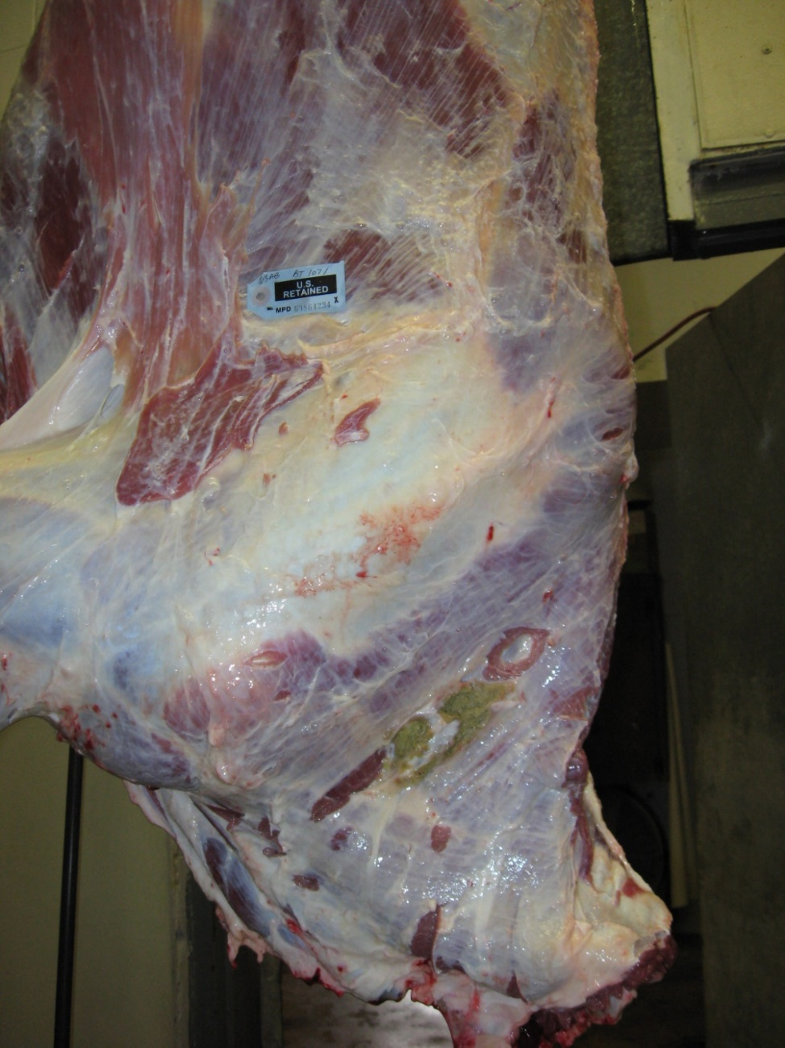

(Above: Cow carcass showing evidence of an injection site in the neck area. As per FSIS Directive 10,800.1 this carcass was retained pending results of residue testing.)

**Photo 2:**

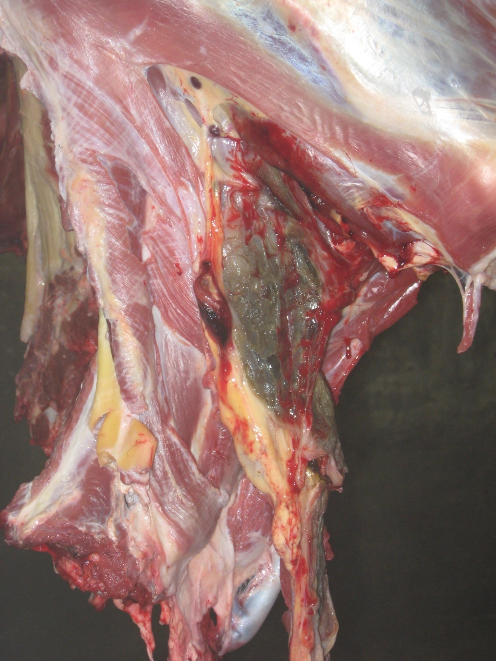

(Above: Cow carcass showing evidence of an injection site in the neck area as evidenced by the green/brown appearance and jelly-like consistency of tissues.)

**Photo 3:**

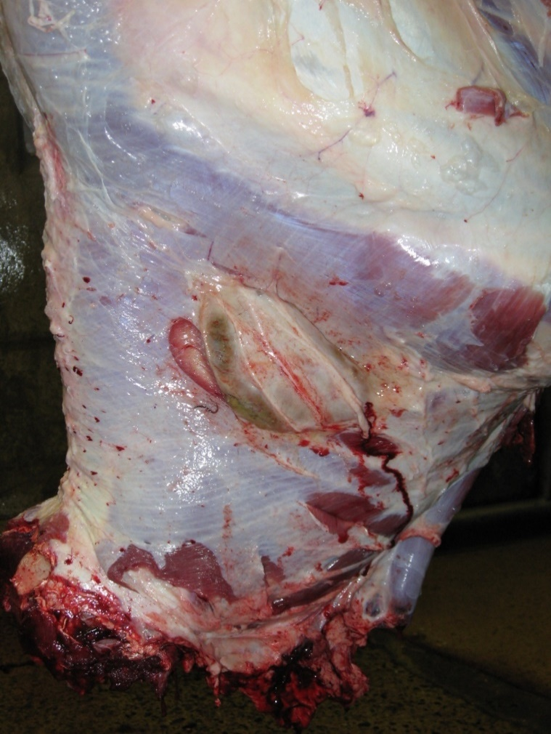

(Above: Cow carcass showing evidence of an injection site in the neck area as evidenced by a raised abscess.

**Photo 4:**

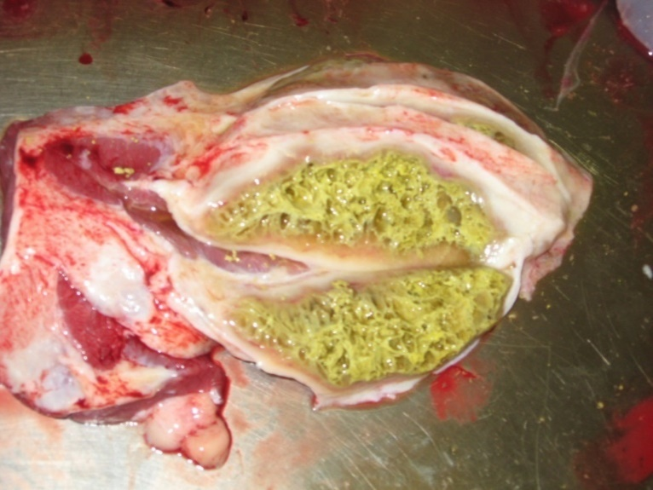

(Above: Cross-section of the abscess shown in Photo 3. Oxytetracycline (LA 200) is an easily accessible antibiotic sold at many farm supply stores that is commonly used in cattle. This antibiotic is yellow in color and typically imparts a yellowish appearance to injection sites.)

**Photo 5:**

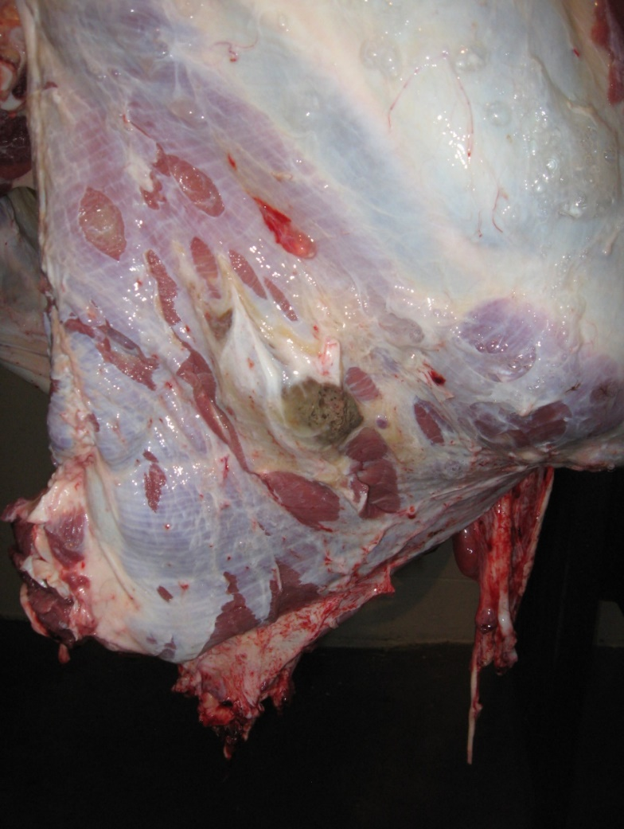

(Above: Cow carcass showing evidence of an injection site in the neck area as evidenced by a raised abscess.)

**Photo 6:**

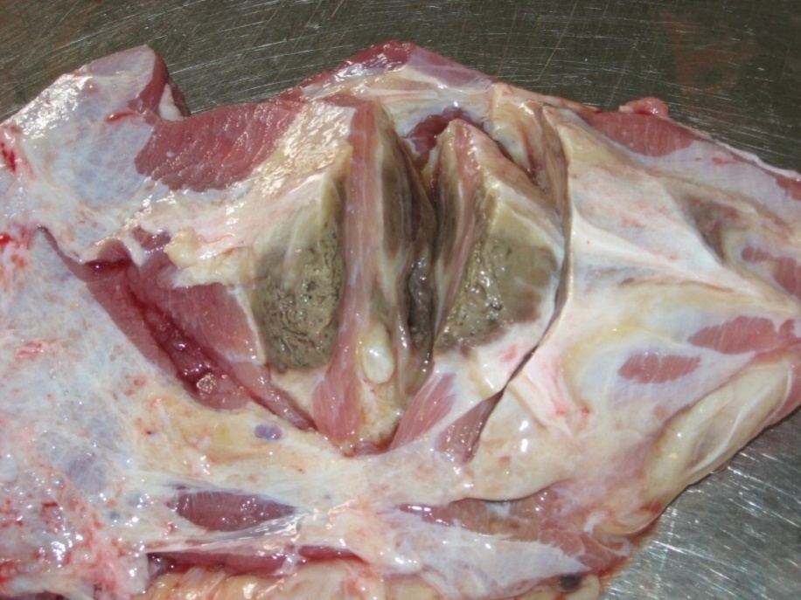

(Above: Cross-section of the abscess shown in Photo 5.)

**Photo 7:**

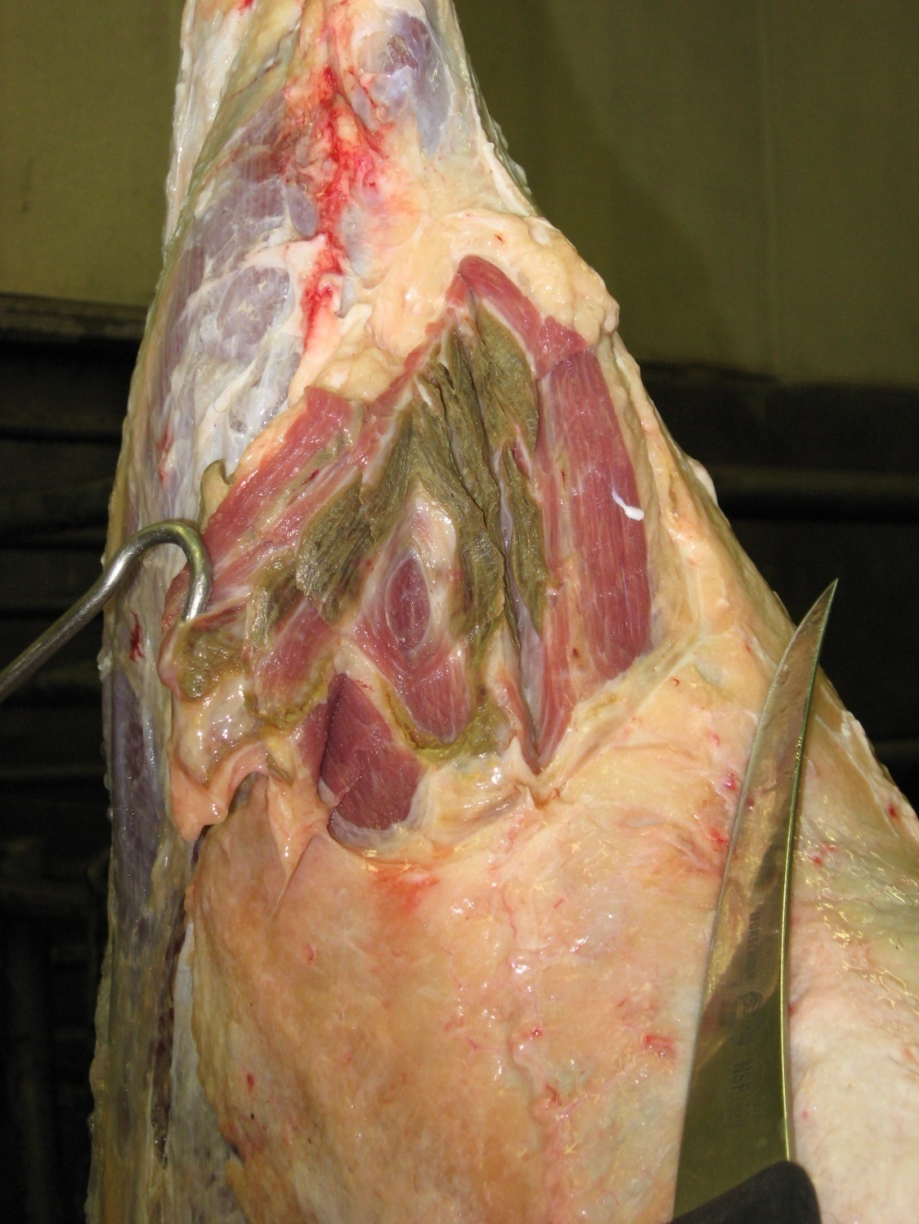

(Above: Cow carcass showing evidence of an injection site in the hip area as evidenced by a green/brown appearance in the meat.)

**Photo 8:**

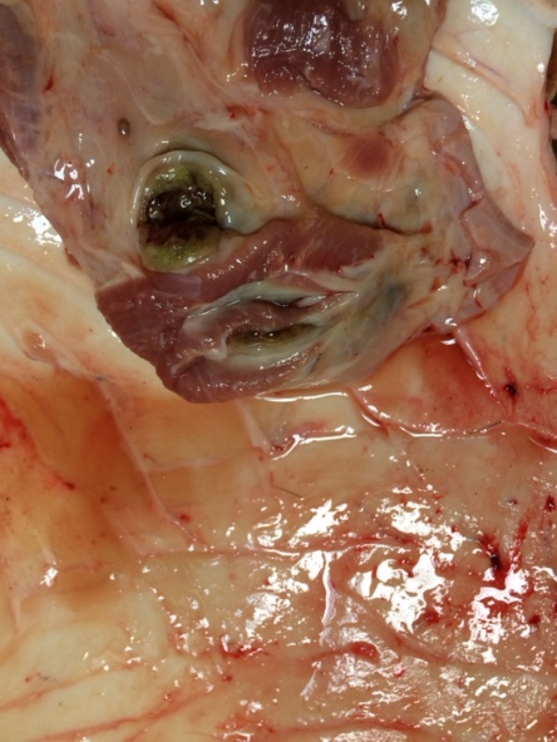

(Above: Cross-section of an injection site that was attached to the hide when it was pulled away from the carcass.)

**Photo 9:**

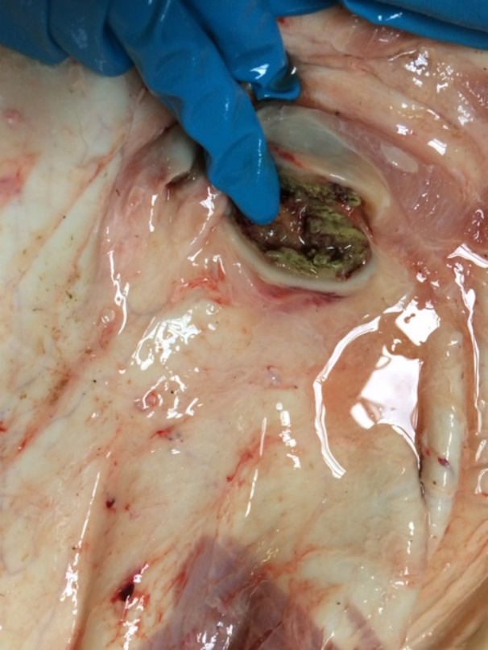

(Above: Cross-section and close-up of injection site that was attached to the hide when it was pulled away from the carcass.)

**Photo 10:**

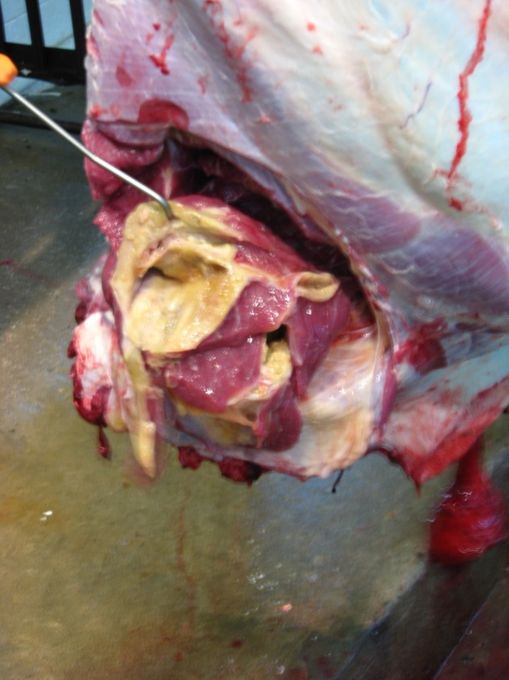

(Above: Cow carcass showing evidence of an injection site in the neck area as evidenced by an abscess in the meat. NOTE: Oxytetracycline (LA 200) is an easily accessible antibiotic sold at many farm supply stores that is commonly used in cattle. This antibiotic is yellow in color and typically imparts a yellowish appearance to injection sites.)

**Photo 11:**

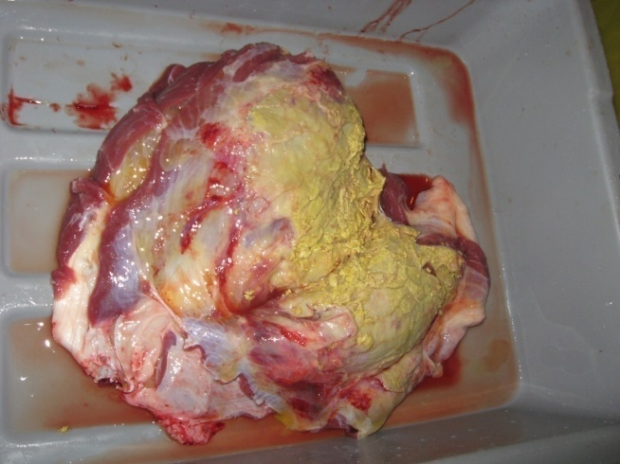

(Above: Appearance of injection site once removed from cow pictured in photo 10 above. NOTE: Oxytetracycline (LA 200) is an easily accessible antibiotic sold at many farm supply stores that is commonly used in cattle. This antibiotic is yellow in color and typically imparts a yellowish appearance to injection sites.)

*Photos provided courtesy of Dr. Michelle Evans (NCDA MPID)