FY2025 Impaired and Impacted

Streams and Watershed Survey

Please review and answer as many of the questions below as possible to the best of your ability. If you are not sure of how to answer a question, contact division staff for assistance (Allie Dinwiddie at alexandra.dinwiddie@ncagr.gov or 919-707-3795).

Completing this survey will allow your district to request Impaired & Impacted Streams Initiative funds from the Agriculture Cost Share Program through your annual Strategic Plan. Survey submittals may remain active for 5 years but should be updated if there are changes in resource concerns and expected projects.

**Survey and Strategic Plan Submittal Deadline is Friday April 12th, 2024**

Disclaimer: Completing this survey is voluntary. Submitted information will help guide resource agency staff to conduct further investigation, assessments, identify funding resources, and/or implement remedial actions.

1. Your district: Click or tap here to enter text.

2. Contact name for survey: Click or tap here to enter text.

3. Phone: Click or tap here to enter text.

4. Email address: Click or tap here to enter text.

WATER QUALITY CONCERNS

5. River Basin Choose an item.

6. HUC (12-Digit Watershed Code): Click or tap here to enter text.

Open the DSWC IISI Survey Webmap - FY25 in a new tab or window.

7. Please select the primary agricultural pollutant contributors to water quality concerns in the watershed specified:
☐Sediment
☐Pathogens (such as E. coli)
☐Excess nutrients (such as nitrogen or phosphorus)
☐Chemical releases/runoff (pesticides, etc.)
☐Other: Click or tap here to enter text.

8. Is this watershed covered by an active local watershed management or action plan?

The NC Division of Water Resources (DWR) keeps limited records of existing local watershed action plans (WAPs) and plans under progress statewide through the WAP mapping application. Records of existing 9-element watershed plans can be found on the DWR supported 9-element plans mapping application or on the DWR NC Watershed Restoration Plans webpage. Open links in a new tab or window to review.

☐ Yes ☐ No

8a. If yes, what remediation efforts does the watershed plan recommend?

8b. Is there local interest in developing a Watershed Action Plan?

☐ Yes ☐ No

8c. Please specify names and contact information for local stakeholders who are interested in being involved with or organizing local watershed planning activities:

Refer to the latest Integrated Water Quality Report documents and mapper tools. You may open these resources in a new tab or window:

DSWC IISI Survey Webmap - FY25 - The 2022 Integrated Report Mapper Tool (separate link below) is a layer within this webmap

Other DWR Relevant Links:

2022 Integrated Report Mapper Tool 2022 303(d) List
2022 Integrated Report Dashboard Tool DWR Integrated Report Landing Page
2020 Integrated Report Dashboard Tool

9. Within the HUC 12 watershed identified above, are there any impaired stream segments on the 303(d) list?

☐Yes ☐ No

9a. Please list the impaired stream name(s) here: Click or tap here to enter text.

9b. Please list the impaired stream(s') Assessment Unit (AU) Number(s) here:
In a new tab, open the DSWC IISI Webmap - FY25 and zoom in enough to see surface waters and 2022 Integrated Report data. Select a water body to open the pop-up and copy the AU Number listed. You can also open the 2022 303(d) list or 2022 Integrated Report Mapper Tool or 2022 Integrated Report Dashboard Tool in new tabs.
Click or tap here to enter text.

9c. Please specify the noted sampling violations in the impaired stream(s):
Refer to the 'Parameter' column in the 303(d) list.
☐Temperature
☐FishCom
☐Benthos
☐Dissolved Oxygen
☐pH
☐Zinc
☐Fecal Coliform
☐Turbidity
☐Other: Click or tap here to enter text.

To guide Districts in making 'Impacted Stream' determinations, DSWC created an IISI Impact List FY2025 Webmap displaying segments of streams that received a 'Data Inconclusive' water quality rating for Fecal Coliform (GM200/400, REC, FW and GM 14 or 43, SH, SA) and Turbidity (10 NTU AL, Tr and 25 NTU AL, FW, SW, and 50 NTU AL, FW) parameters in the 2022 Integrated Reporting Cycle. Some segments included on this map exceeded other water quality criteria and subsequently were included on the state's 303(d) list for 2022 regardless of their 'Category 3 - Data Inconclusive' primary IRC rating for turbidity or fecal coliform parameters. Streams on the webmap that did not exceed other water quality criteria could be 'Impacted Streams'. Districts may also identify streams not included in the webmap as 'Impacted'.

10. Are there any streams within the watershed not on the 303(d) list, that your district feels is particularly impacted by agriculture activity or other sources of impairment?

☐Yes ☐No

10a. Please list one or more impacted stream names within the watershed.
Click or tap here to enter text.

10b. Please specify the water quality concerns in the impacted streams identified above:
☐Sediment
☐Pathogens (such as E. coli)
☐Excess nutrients (such as nitrogen or phosphorus)
☐Chemical releases/runoff (pesticides, etc.)
☐Other: Click or tap here to enter text.

11. Check the items listed below if they appear in the impaired or impacted streams specified above:
☐Livestock access
☐Animal feedlot
☐Pesticide mixing stations
☐Outfall pipes and sources (stormwater, septic systems, unknown, etc.)
☐Permitted discharges (NPDES)
☐Development and Construction
☐Fish hatchery or farms
☐Periods of no flow
☐Swamp drainage
☐Logging
☐Not applicable
☐Other: Click or tap here to enter text.

Add any information here that helps describe the current water quality problems within the identified watershed or impaired or impacted stream segments specified above.

12. Additional information:

RESOURCE NEEDS & DISTRICT ACTIVITY

Please give us a sense of the kinds of projects and/or programs which would be most effective at addressing the most pressing water quality problems in the watershed identified and within impaired or impacted stream segments.

Information specified in this section may be used in efforts to secure grant funding outside our regular Cost Share Programs, so please be specific.

13. Identify up to five priority BMPs needed on the impaired or impacted stream segments or within the watershed. Identify expected funding sources for specified BMPs and estimate BMP extent and cost.

For example:

BMP Name | Quantity | Unit | Cost | Funding Source
Livestock Exclusion Fencing | 3,000 | Linear Feet | $15,000 | ACSP/Cooperator

If outside grants are needed/expected to fund BMP implementation, please either specify the grant program name to be used or type in 'outside grant'.

 | BMP Name | Quantity | Unit | Cost | Funding Source
BMP#1
BMP#2
BMP#3
BMP#4
BMP#5

14. Please select the three most significant potential barriers or limiting factors for implementing BMPs and mitigating identified problems in the watershed:

- Largest potential barrier or limiting factor: Choose an item.

- Second largest potential barrier or limiting factor: Choose an item.

- Third largest potential barrier or limiting factor: Choose an item.

If you selected 'Other Barrier' for any of the dropdown fields above, describe the other barrier(s):

15. List up to five resources (other than BMP cost share dollars) needed by your district to address the identified water quality problems. Include the Item (Staff - intern, part-time, full-time, Equipment, Supplies/Materials, Outside Technical Assistance, etc.), Quantity/Units Needed, and Estimated Cost ($).

For example:

Item Name | Quantity | Unit | Cost
Part time staff | 100 | Hours | $2,000
No-till drill | 1 | Each | $20,000

If outside grants are needed/expected to fund BMP implementation, please either specify the grant program name to be used or type in 'outside grant'.

 | Item Name | Quantity (eg # of Each, # of Hours, etc) | Units of Specified Quantity (eg Hours, Each, etc.) | Cost ($)
Item#1
Item#2
Item#3
Item#4
Item#5

16. Does your district have outstanding ACSP requests in this watershed?

☐Yes ☐ No

Note: If you do not answer "Yes" to the question above, your district is not eligible for II funds. New Impaired and Impacted Streams Initiative program policy requires Districts affirm in Strategic Plan submittals that they have outstanding requests OR a waitlist of one or more applicants for ACSP/II funds in prioritized watersheds to receive II funds.

17. Is this watershed prioritized on your district's ACSP ranking form?

☐Yes ☐ No

Note: If you do not answer "Yes" to the question above, your district is not eligible for II funds. New Impaired and Impacted Streams Initiative program policy requires Districts update their local ACSP ranking form to prioritize funding implementation in the prioritized watersheds specified in Strategic Plan submittals.

'Prioritize Impaired/Impacted watersheds in ACSP ranking forms' means that district-designated Impaired/Impacted watersheds are specifically called out and assigned points within local ACSP ranking forms such that ACSP projects in these watersheds are prioritized more for funding.

Forms that assign points to Impaired/Impacted watersheds and an equal number of points to 'All Other Watersheds' in the county do not meet this policy as they do not function to prioritize funding toward ACSP projects in Impaired/Impacted watersheds.

17a. If no, please describe the IISI ranking criteria to be added to your district's ACSP ranking form for FY25:
You may also upload a draft of your district's proposed FY25 ACSP ranking form under Q18.

17b. If yes, please describe the IISI ranking criteria already within your district's ACSP ranking form for FY25:
You may also upload a draft of your district's proposed FY25 ACSP ranking form under Q18.

18. Please upload digital photos of the resource concerns in the watershed here. Please see acceptable photo examples below.
You may also upload any other relevant information. This can include a draft of your district’s FY25 ACSP ranking form, GIS shape/projection files, maps, BMP data, or other documentation to support justification for Impaired or Impacted Streams Initiative funding or use the District AGOL tool to document projects.

Examples of Acceptable Field or Aerial Photos of Resource Concerns for Q18:
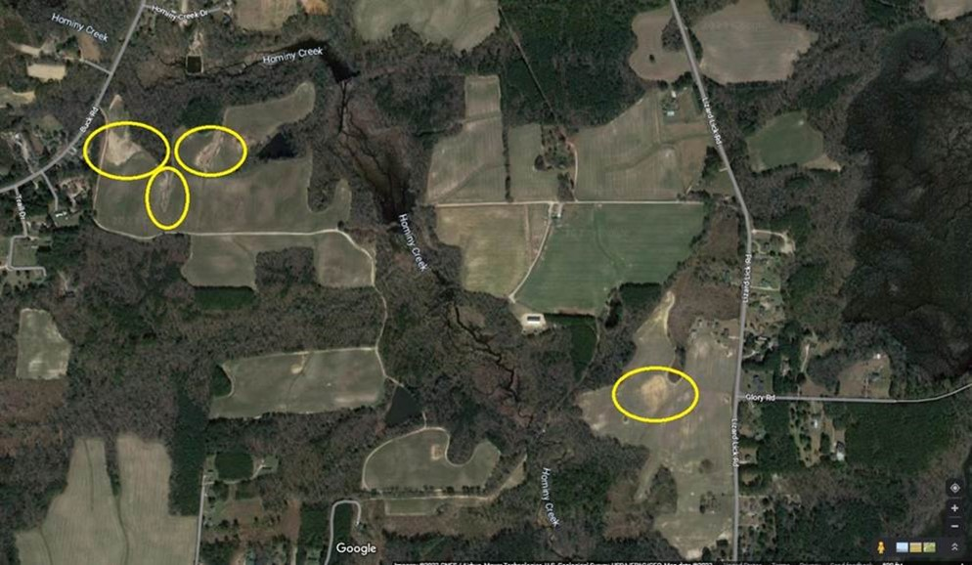
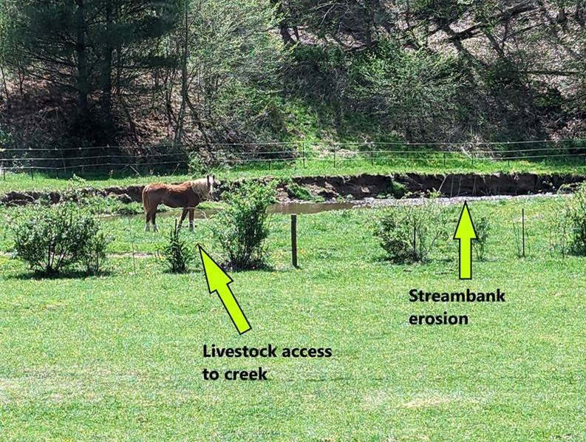
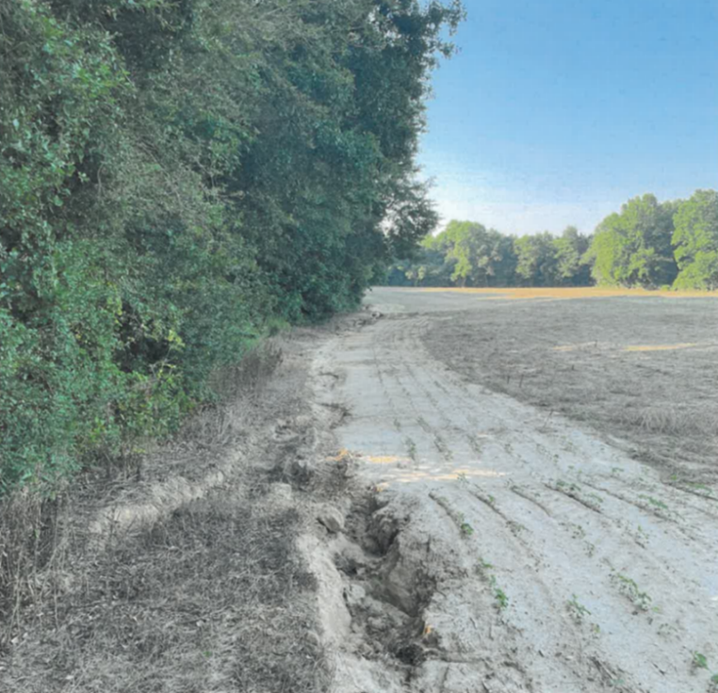

Planning & Grant Funding

Information specified in this section may be used in efforts to secure grant funding outside our regular Cost Share Programs.

19. To your knowledge, has this watershed received grant funding in the past for agriculture nonpoint source pollution prevention planning or BMP implementation projects?

☐Yes ☐No

20. Does your district have shovel-ready projects in this watershed in need of additional funding?

☐Yes ☐ No

20a. Please describe the projects(s):

21. Is there local interest in working with neighboring districts/counties in pursuing grant funding for cross-county nonpoint source pollution prevention projects, including additional cost share dollars for ACSP BMPs, in this sub-watershed or the larger watershed/sub-basin?

☐Yes ☐ No

Districts must annually request an amount of Impaired and Impacted Streams Initiative (IISI) funds to receive for the upcoming Fiscal Year through Strategic Plan submittals. To be eligible for IISI funds, in Strategic Plan submittals Districts must also prioritize up to three HUC-12 watershed(s) with completed Impaired and Impacted Streams and Watershed Surveys in which they plan to use IISI funds annually and must affirm that they currently have outstanding requests in the prioritized watersheds for ACSP/IISI funds.

Thank you for completing this survey!

These recommendations will be used to help develop proposals for additional funding through Commission Cost Share Programs, Section 319 grants, Land and Water Trust Fund, and other grant sources. Survey results will also help DSWC and DWR's Basinwide Planning Program to assist those interested in developing local watershed plans.

Please contact Allie Dinwiddie (919-707-3795) for assistance as needed or email Allie at alexandra.dinwiddie@ncagr.gov.

